**Calculator Assumed**

**Relative Frequency, Probability and Tree Diagrams**

Time: 45 minutes

Total Marks: 45

Your Score: / 45



**Question One: [1, 1, 2, 2 = 6 marks]**

On an episode of Family Feud, contestants were asked to guess the top seven responses to the following survey question:

“Name an occupation starting with the letter B.”

The Smith family correctly guessed all the responses of the survey and won that round. The responses were as follows:

|  |  |  |  |
| --- | --- | --- | --- |
| Builder | 37 | Barista | 6 |
| Baker | 24 | Bus Driver | 5 |
| Bricklayer | 15 |  |  |
| Butcher | 7 |  |  |
| Beautician | 6 |  |  |

1. In each round of Family Feud, the same number of people have been surveyed on each question. How many people in the Australian population are surveyed?
2. Based on the above survey results, what percentage of the general Australian population are likely to answer “Bricklayer” to the given survey question?
3. If 500 people in Perth are asked the same survey question, how many are likely to respond with “Butcher”?
4. Amy asks all the 180 students in her year group this survey question. How many are likely to respond with “Barista”?

**Question Two: [3, 6 = 9 marks]**

Tristan is the last one at a birthday party to choose two wrapped gifts from the “lucky dip” bag. When it’s his turn there are 2 toy cars, a bracelet, a doll, a pack of cards and a puzzle left in the bag.

He puts his hand in the bag without looking, chooses a wrapped gift, puts it aside and then returns his hand to the bag to choose his second wrapped gift.

1. Draw a tree diagram to represent all possible combinations of the gifts Tristan could select.
2. Determine the probability that Tristan chooses:

(i) two toy cars

(ii) a doll and a puzzle

(iii) a bracelet or a toy car

(iv) a puzzle if his first gift was a toy car.

**Question Three: [3, 5 = 8 marks]**

Craig and Emily went to Interlaken in Switzerland for a white winter Christmas holiday. As part of their itinerary, there is a sleigh ride scheduled for Christmas Day, 25th December, if there’s enough snow on the ground.

The historical chance of snow on the ground on 25th December is 65%. If there is snow on the ground, then they are 95% certain to go on a sleigh ride that day. If there isn’t snow on the ground, then there is an 80% chance that an alternate activity will be organized.

1. Complete the tree diagram below to represent this situation.

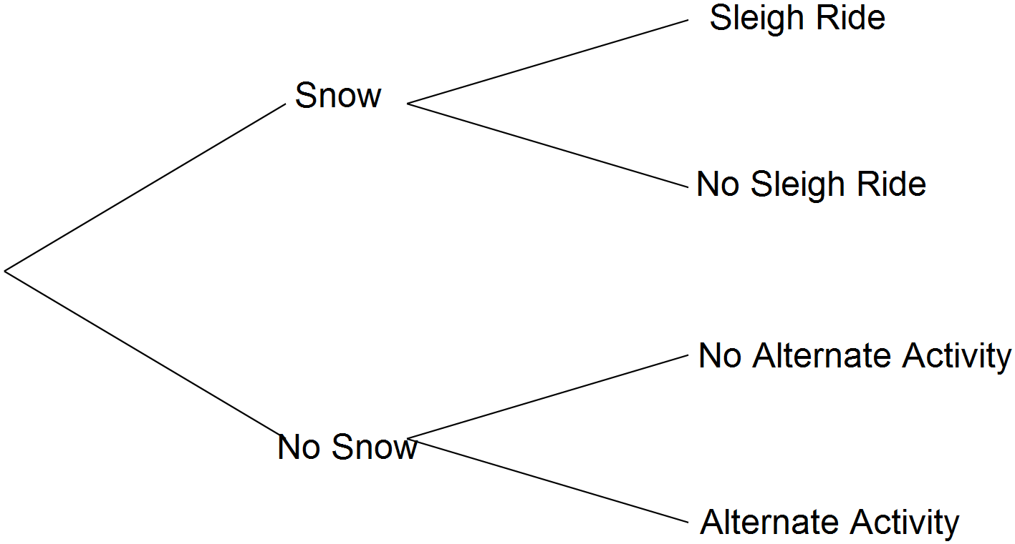

1. Calculate the probability that on 25th December Craig and Emily:

(i) go for a sleigh ride

(ii) have no activity planned for that day

(iii) experience snow on the ground given that they have no activity planned for that day.

**Question Four: [1, 2, 3, 3 = 9 marks]**

In 2014, a travel agent booked 4000 flights for passengers flying from Sydney to Rome. She recorded whether clients preferred to travel via Dubai or Singapore and whether clients tended to spend in the range of $1500 - $1900 for a return journey, or $1900 - $2300. The results are tabulated below.

|  |  |  |  |  |
| --- | --- | --- | --- | --- |
|  |  | Prefer to travel via: | | Total |
|  |  | Dubai | Singapore |
| Prefer to spend between: | $1500-$1900 | 1265 | 1035 | 2300 |
| $1900-$2300 | 935 | 765 | 1700 |
| Total | | 2200 | 1800 | 4000 |

1. Calculate the probability of a randomly selected client in 2015 flying the same route will chose to fly via Singapore.
2. The travel agent has booked 1200 flights from Sydney to Rome in 2015. How many of these do you expect to be in the $1500-$1900 price range?
3. Of those who booked flights in the $1500-$1900 price range, what percentage flew via Dubai?
4. The travel agent wonders whether the choice by more clients to fly via Dubai is influenced by the price of these airlines. Is the choice to fly via Dubai independent of the choice to spent between $1900-$2300? Justify your answer with full mathematical reasoning.

**Question Five: [4, 7, 2 = 13 marks]**

Each morning when Harvey Specter gets dressed for work, he chooses one of his 50 ties at random.

If he chooses the same tie as he wore yesterday, there is a 4 in 5 chance he will put it back and choose again.

If the tie is different to what he wore yesterday, there is a 1 in 10 chance he will put it back and choose again.

1. Draw a tree diagram to represent Harvey’s daily scenario.
2. Calculate the probability that Harvey:

(i) chooses the same tie as yesterday and decides to wear it.

(ii) decides to choose a different tie after his initial selection.

(iii) chose a tie different from yesterday given that he didn’t put his initial selection back.

(iv) put his initial selection back given that he initially chose the same tie as

yesterday.

1. Comment on what your answer in part (b) (iv) suggests about the relationship between these two occurrences.

**SOLUTIONS**

**Calculator Assumed**

**Relative Frequency, Probability and Tree Diagrams**

Time: 45 minutes

Total Marks: 45

Your Score: / 45



**Question One: [1, 1, 2, 2 = 6 marks]**

On an episode of Family Feud, contestants were asked to guess the top seven responses to the following survey question:

“Name an occupation starting with the letter B.”

The Smith family correctly guessed all the responses of the survey and won that round. The responses were as follows:

|  |  |  |  |
| --- | --- | --- | --- |
| Builder | 37 | Barista | 6 |
| Baker | 24 | Bus Driver | 5 |
| Bricklayer | 15 |  |  |
| Butcher | 7 |  |  |
| Beautician | 6 |  |  |

1. In each round of Family Feud, the same number of people have been surveyed on each question. How many people in the Australian population are surveyed?

100 people

1. Based on the above survey results, what percentage of the general Australian population are likely to answer “Bricklayer” to the given survey question?

15%

1. If 500 people in Perth are asked the same survey question, how many are likely to respond with “Butcher”?

7% of 500 = 35 people



1. Amy asks all the 180 students in her year group this survey question. How many are likely to respond with “Barista”?



6% of 180 = 10.8

Therefore about 11 people.

**Question Two: [3, 6 = 9 marks]**

Tristan is the last one at a birthday party to choose two wrapped gifts from the “lucky dip” bag. When it’s his turn there are 2 toy cars, a bracelet, a doll, a pack of cards and a puzzle left in the bag.

He puts his hand in the bag without looking, chooses a wrapped gift, puts it aside and then returns his hand to the bag to choose his second wrapped gift.

1. Draw a tree diagram to represent all possible combinations of the gifts Tristan could select.

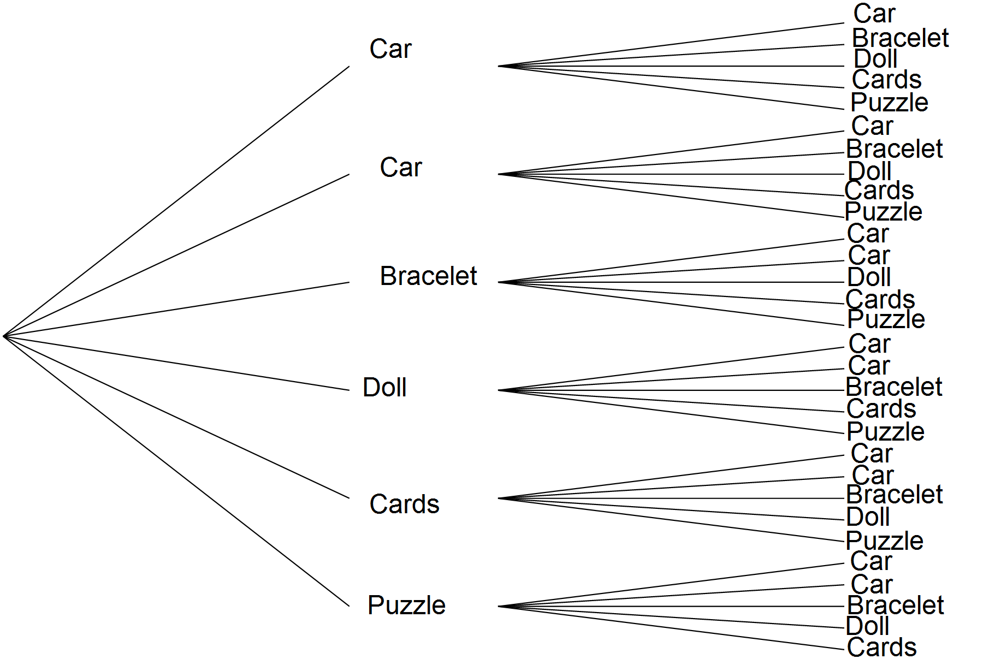







1. Determine the probability that Tristan chooses:

(i) two toy cars

 

(ii) a doll and a puzzle

 

(iii) a bracelet or a toy car

 

(iv) a puzzle if his first gift was a toy car.

 

**Question Three: [3, 5 = 8 marks]**

Craig and Emily went to Interlaken in Switzerland for a white winter Christmas holiday. As part of their itinerary, there is a sleigh ride scheduled for Christmas Day, 25th December, if there’s enough snow on the ground.

The historical chance of snow on the ground on 25th December is 65%. If there is snow on the ground, then they are 95% certain to go on a sleigh ride that day. If there isn’t snow on the ground, then there is an 80% chance that an alternate activity will be organized.

1. Complete the tree diagram below to represent this situation.

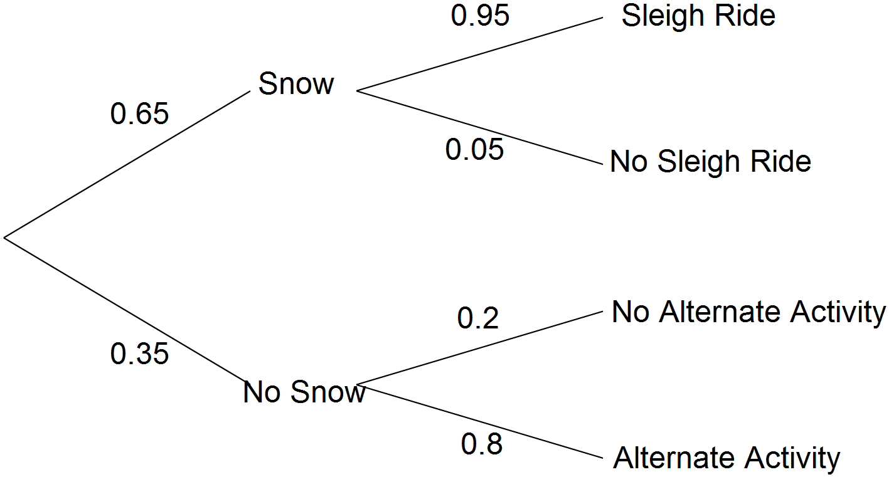







1. Calculate the probability that on 25th December Craig and Emily:

(i) go for a sleigh ride



(ii) have no activity planned for that day





(iii) experience snow on the ground given that they have no activity planned for that day.

 

**Question Four: [1, 2, 3, 3 = 9 marks]**

In 2014, a travel agent booked 4000 flights for passengers flying from Sydney to Rome. She recorded whether clients preferred to travel via Dubai or Singapore and whether clients tended to spend in the range of $1500 - $1900 for a return journey, or $1900 - $2300. The results are tabulated below.

|  |  |  |  |  |
| --- | --- | --- | --- | --- |
|  |  | Prefer to travel via: | | Total |
|  |  | Dubai | Singapore |
| Prefer to spend between: | $1500-$1900 | 1265 | 1035 | 2300 |
| $1900-$2300 | 935 | 765 | 1700 |
| Total | | 2200 | 1800 | 4000 |

1. Calculate the probability of a randomly selected client in 2015 flying the same route will chose to fly via Singapore.



1. The travel agent has booked 1200 flights from Sydney to Rome in 2015. How many of these do you expect to be in the $1500-$1900 price range?





1. Of those who booked flights in the $1500-$1900 price range, what percentage flew via Dubai?





1. The travel agent wonders whether the choice by more clients to fly via Dubai is influenced by the price of these airlines. Is the choice to fly via Dubai independent of the choice to spent between $1900-$2300? Justify your answer with full mathematical reasoning.

 Yes, they are independent.

**Question Five: [4, 7, 2 = 13 marks]**

Each morning when Harvey Specter gets dressed for work, he chooses one of his 50 ties at random.

If he chooses the same tie as he wore yesterday, there is a 4 in 5 chance he will put it back and choose again.

If the tie is different to what he wore yesterday, there is a 1 in 10 chance he will put it back and choose again.

1. Draw a tree diagram to represent Harvey’s daily scenario.



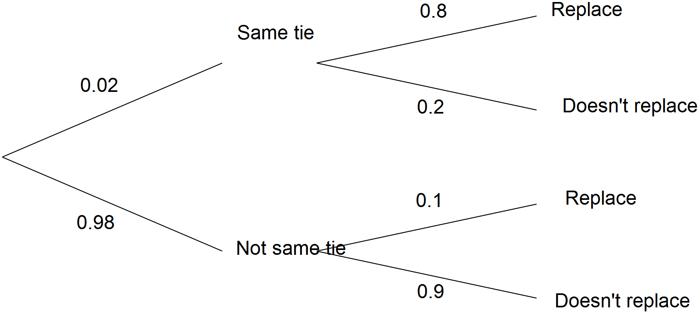







1. Calculate the probability that Harvey:

(i) chooses the same tie as yesterday and decides to wear it.



(ii) decides to choose a different tie after his initial selection.





(iii) chose a tie different from yesterday given that he didn’t put his initial selection back.









(iv) put his initial selection back given that he initially chose the same tie as

yesterday.







1. Comment on what your answer in part (b) (iv) suggests about the relationship between these two occurrences.



Independent